**ARYAMAN MISHRA**

**19BCE1027**

1. **Aim:**Draw a polygon and change the shape of that polygon into another using any 3D animation software.

**SOFTWARES USED**:BLENDER AND AFTER EFFECTS

**1st animation**

**Link:** https://drive.google.com/drive/folders/1SRU0lv4t_xAWLoyRUw5ZBX4mIh_5FCcG?usp=sharing

**Progress:**

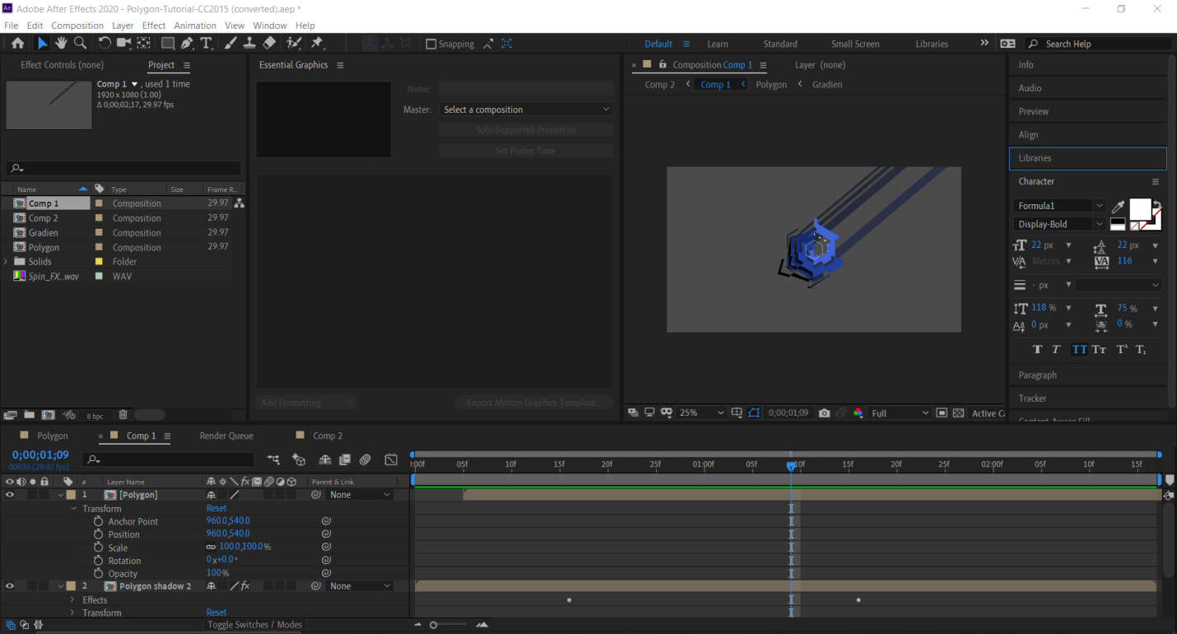

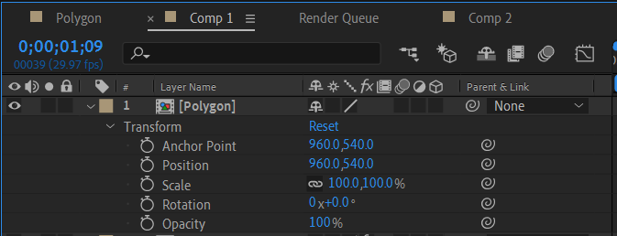

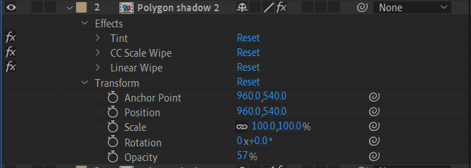

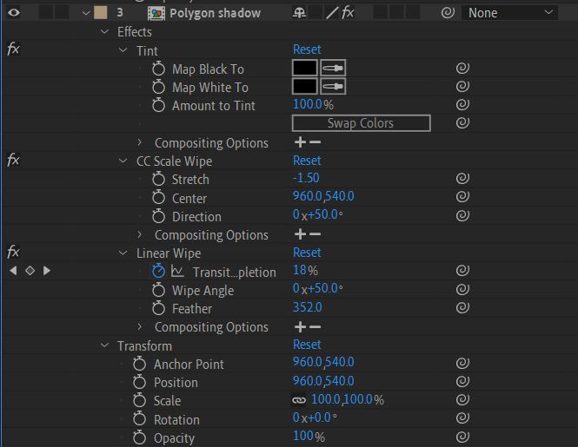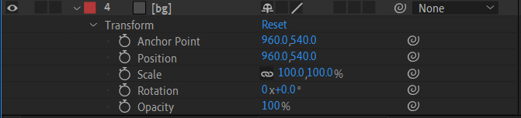

**OUTPUT:**





2nd Animation(BLENDER)

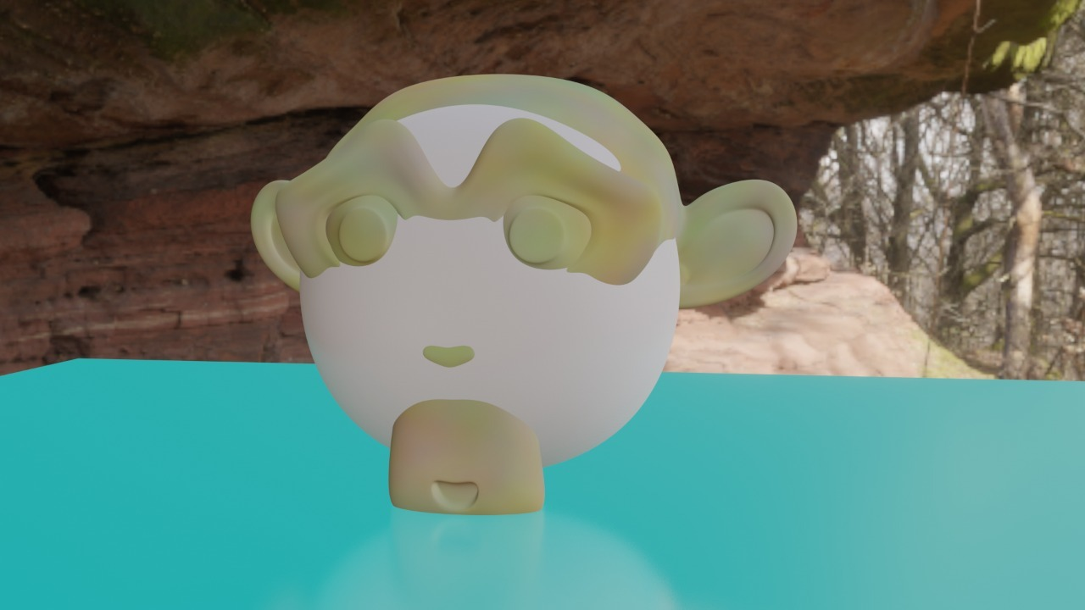

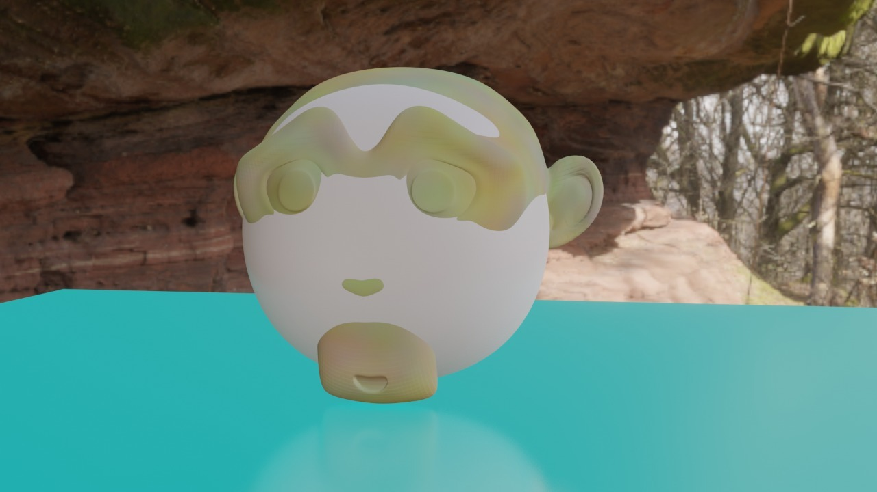

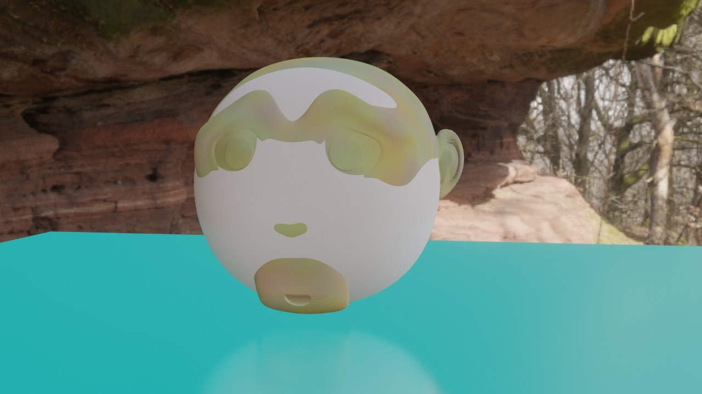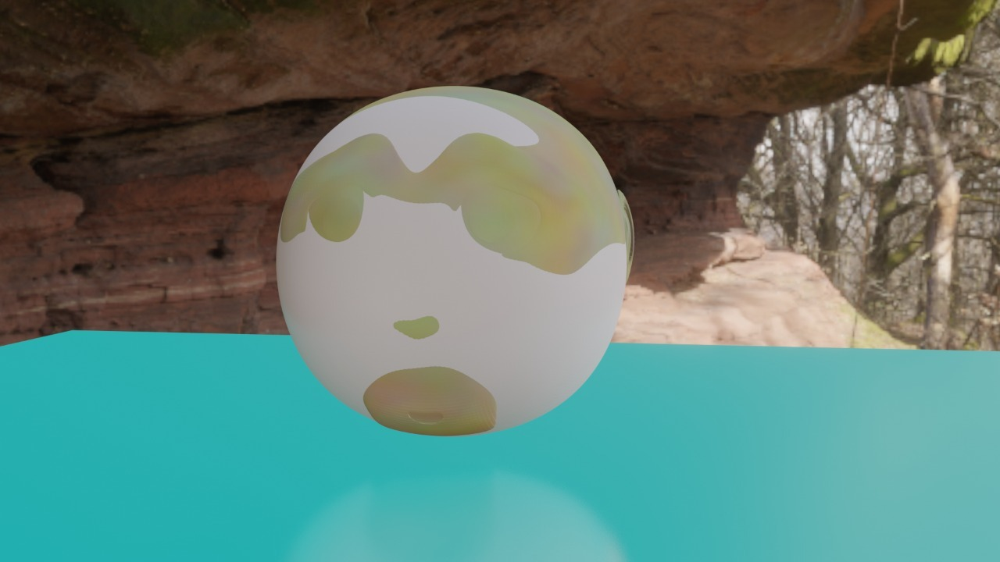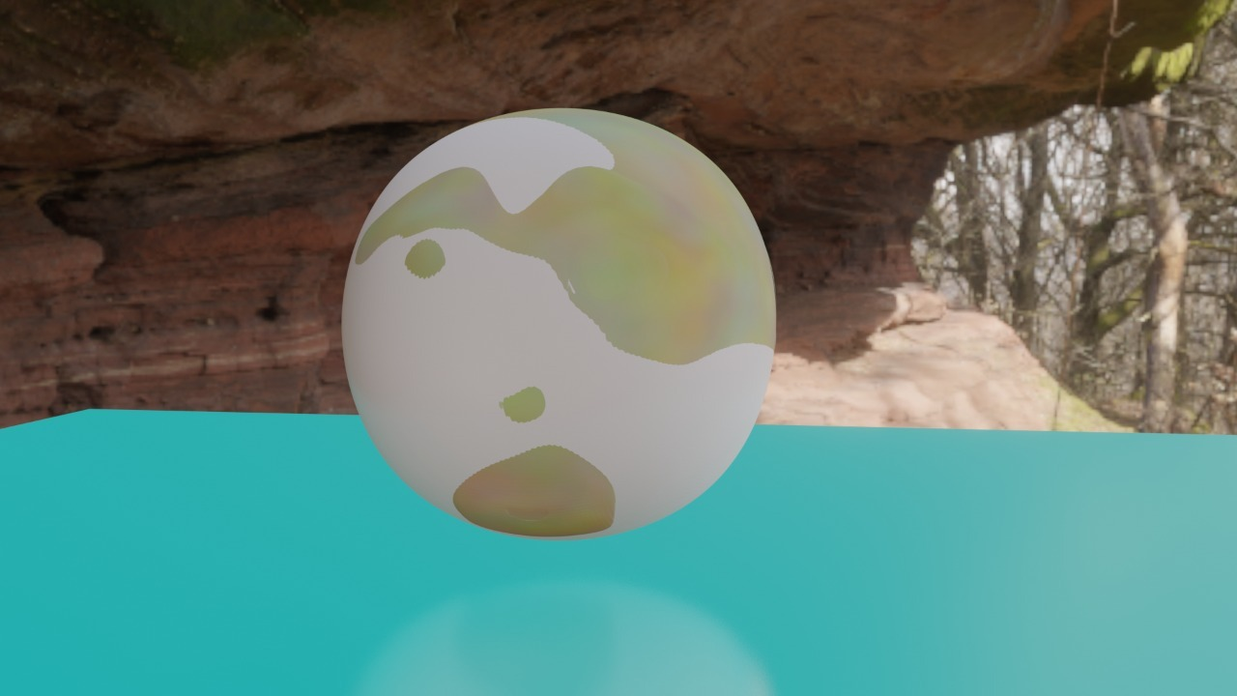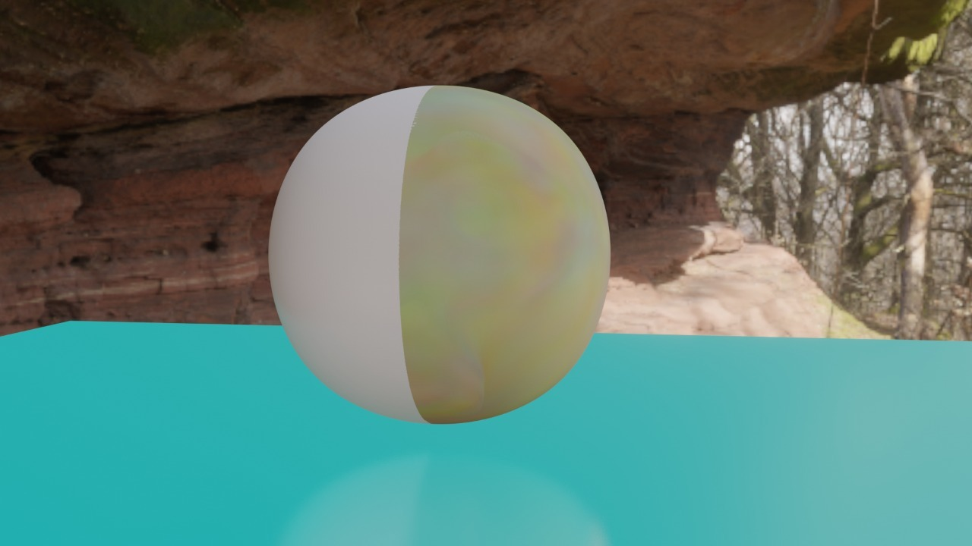



2.Aim: Write a program to draw all the basic shapes using C.

Code:

#include<graphics.h>

#include<conio.h>

void main()

{

int gd=DETECT,gm;

initgraph (&gd,&gm,"c:\\turboc3\\bgi");

setbkcolor(RED);

printf("\t\t\t\n\nLINE");

line(50,40,190,40);

printf("\t\t\n\n\n\nRECTANGLE");

rectangle(125,115,215,165);

printf("\t\t\t\n\n\n\n\n\n\nARC");

arc(120,200,180,0,30);

printf("\t\n\n\n\nCIRCLE");

circle(120,270,30);

printf("\t\n\n\n\nECLIPSE");

ellipse(120,350,0,360,30,20);

getch();

}

**OUTPUT:**

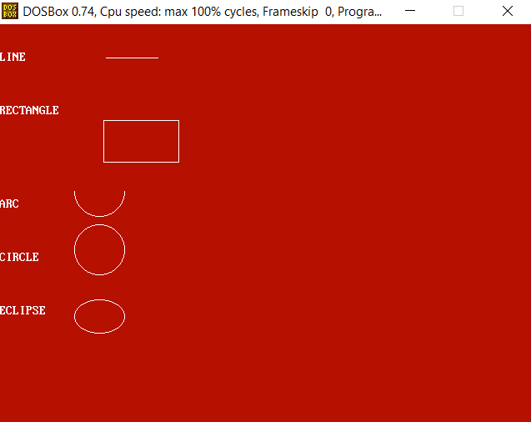

RESULT:

Animation and Program has been completed.